Appendix 3:
PID Implementation

Process

Controller

r
e
m
c

r = set point
e = error = r – c
m = manipulated variable
c = controlled variable

Controller
e
m

P Controller

K_{P}
e
m
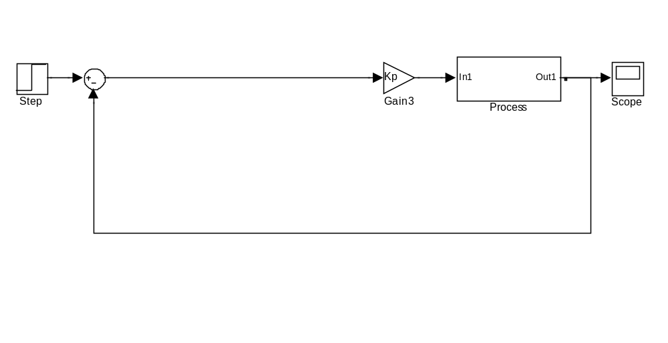
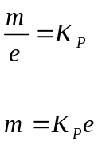

c = get_c();
e = r-c;
m = Kp*e;

PI Controller 1
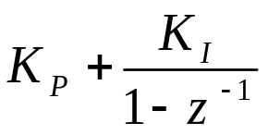
e
m
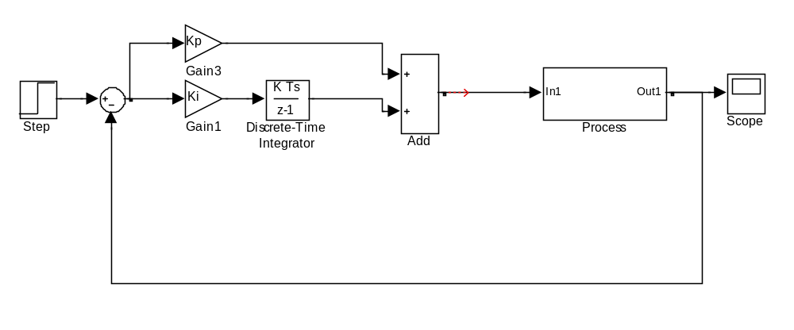
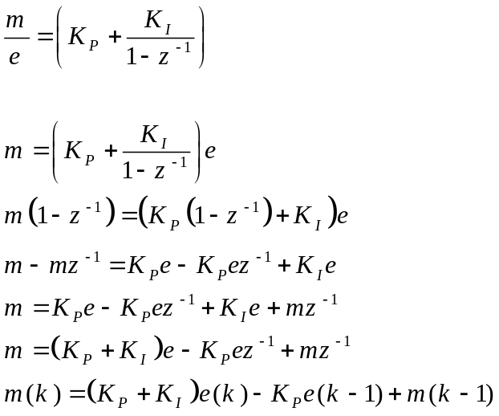

c = get_c();
e = r-c;
e_sum = e_sum + e;
m = Kp*e + Ki*e_sum;

OR

e_prev = e;
m_prev = m;
c = get_c();
e = r-c;
m = (Kp + Ki)*e – Kp*e_prev + m_prev;

PI Controller 2
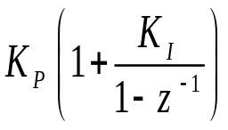
e
m
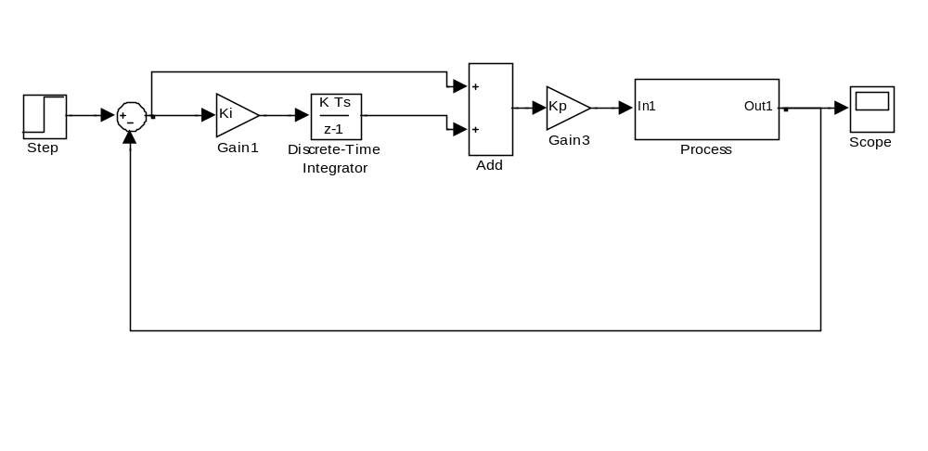
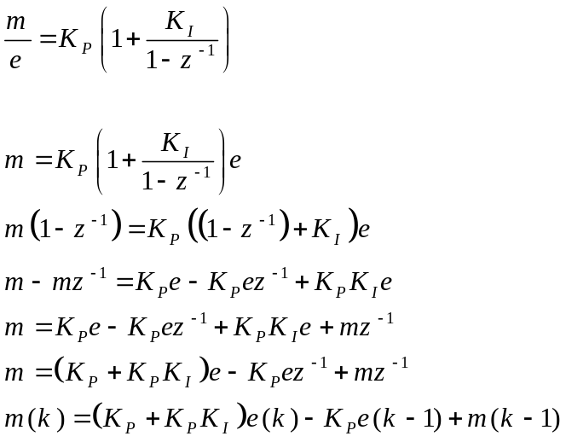

c = get_c();
e = r-c;
e_sum = e_sum + e;
m = Kp*(e + Ki*e_sum);

OR
e_prev = e;
m_prev = m;
c = get_c();
e = r-c;
m = (Kp + Kp*Ki)*e – Kp*e_prev + m_prev;

PID Controller 1
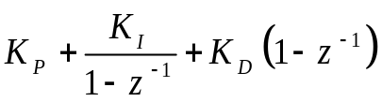
e
m

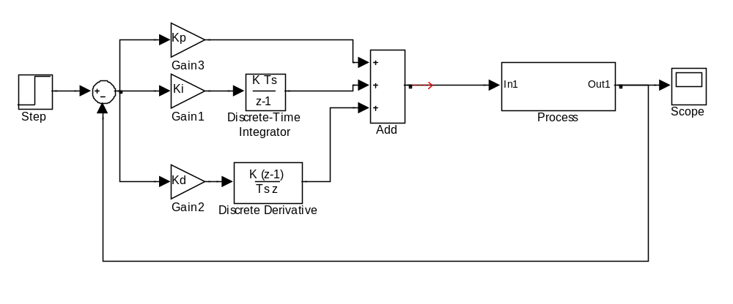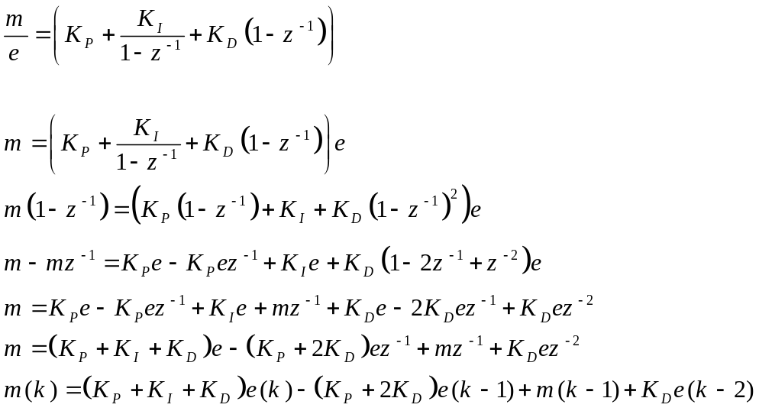
e_prev = e;
c = get_c();
e = r-c;
e_sum = e_sum + e;
m = Kp*e + Ki*e_sum + Kd*(e-e_prev);

OR

e_prev_prev = e_prev;
e_prev = e;
m_prev = m;
c = get_c();
e = r-c;
m = (Kp+Ki+Kd)*e–(Kp+2Kd)*e_prev+m_prev+Kd*e_prev_prev;

PID Controller 2
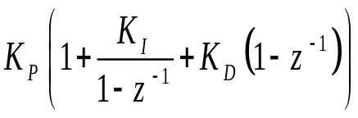
e
m
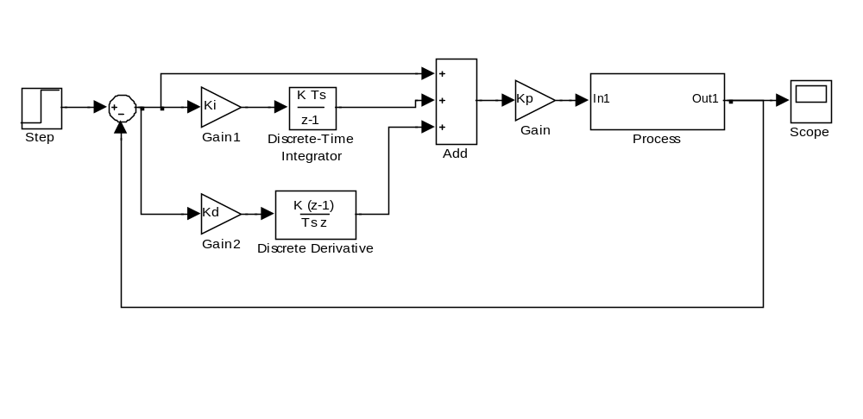
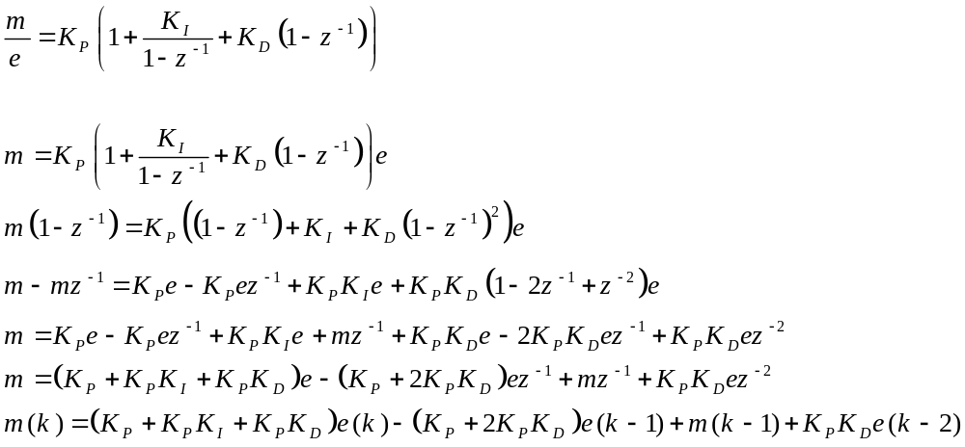
e_prev = e;
c = get_c();
e = r-c;
e_sum = e_sum + e;
m = Kp*(e + Ki*e_sum + Kd*(e-e_prev));
OR
e_prev_prev = e_prev;
e_prev = e;
m_prev = m;
c = get_c();
e = r-c;
m = (Kp + Kp*Ki + Kp*Kd)*e – (Kp + 2Kp*Kd)*e_prev + m_prev + Kp*Kd*e_prev_prev;

PID Controller 3
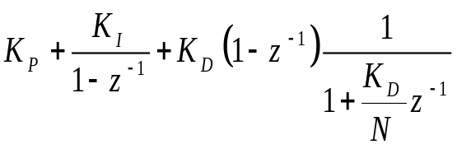
e
m

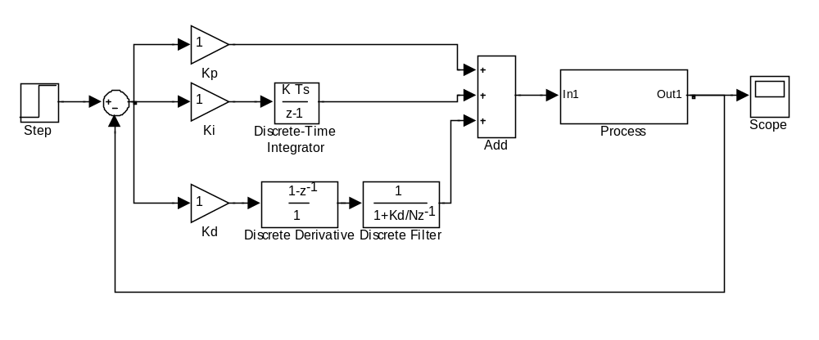
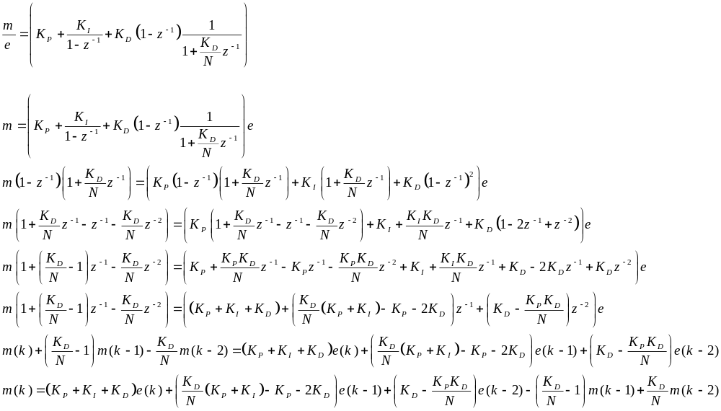

e_prev = e;
c = get_c();
e = r-c;
e_sum = e_sum + e;
m1_prev = m1;
m1 = Kd*(e-e_prev) – Kd/N*m1_prev;
m = Kp*e + Ki*e_sum + m1;

OR

e_prev_prev = e_prev;
e_prev = e;
m_prev_prev = m_prev;
m_prev = m;
c = get_c();
e = r-c;
m = (Kp+Ki+Kd)*e–(Kd/N*(Kp+Ki)-Kp-2Kd)*e_prev +
(Kd-Kp*Kd/N)*e_prev_prev – (Kd/N-1)*m_prev + Kd/N*m_prev_prev;

PID Controller 4
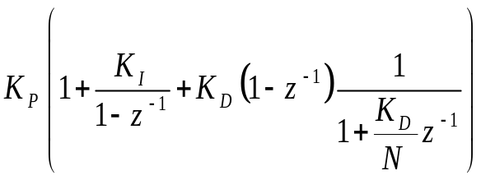
e
m

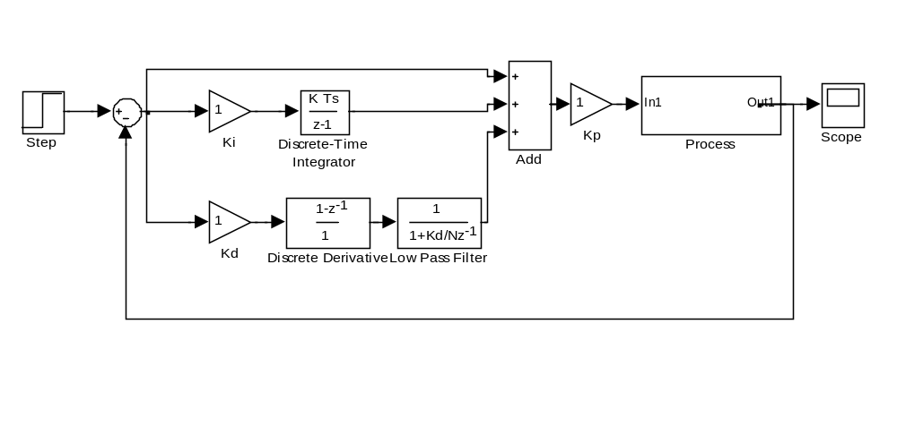
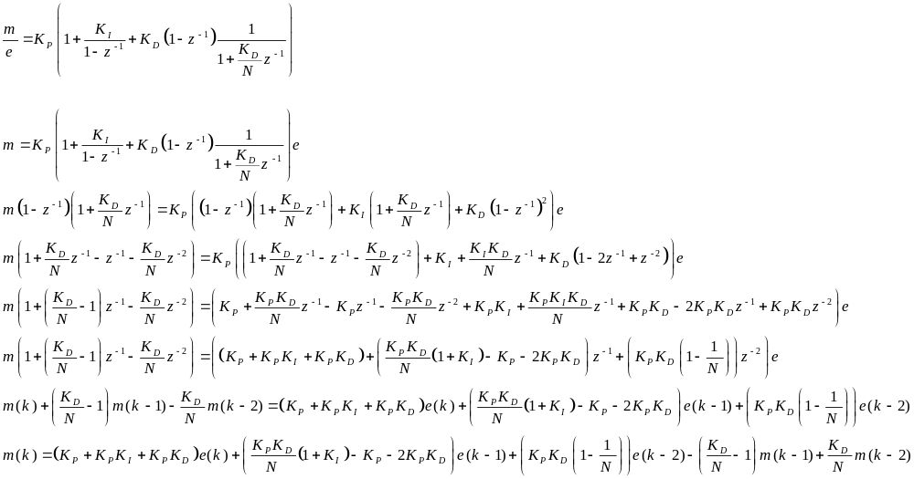
e_prev = e;
c = get_c();
e = r-c;
e_sum = e_sum + e;
m1_prev = m1;
m1 = Kd*(e-e_prev) – Kd/N*m1_prev;
m = Kp*(e + Ki*e_sum + m1);

OR

e_prev_prev = e_prev;
e_prev = e;
m_prev_prev = m_prev;
m_prev = m;
c = get_c();
e = r-c;
m = Kp(1+Ki+Kd)*e–Kp*(Kd/N*(1+Ki)-1-2Kd)*e_prev +
Kp*Kd(1-1/N)*e_prev_prev – (Kd/N-1)*m_prev + Kd/N*m_prev_prev;

Enhancement 1.0 : Derivative Action Suppressing for Error Step Changes

Process

Controller

r
e
m
c
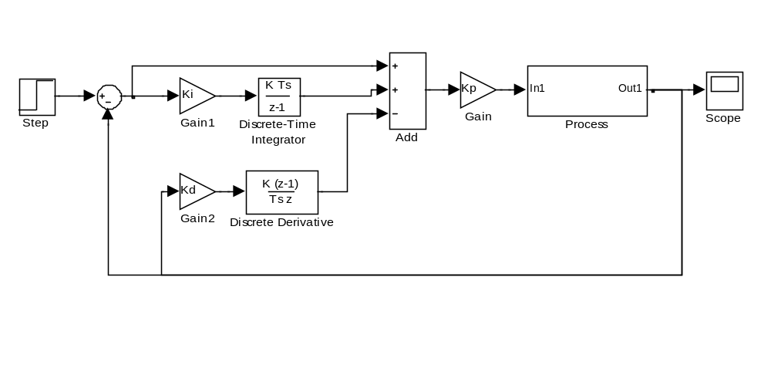
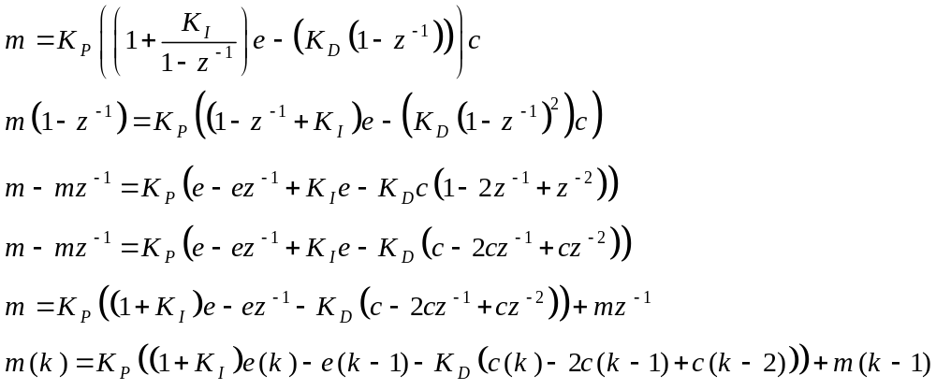

c_prev = c;
c = get_c();
e = r-c;
e_sum = e_sum + e;
m = Kp*(e + Ki*e_sum – Kd*(c – c_prev));

OR

c_prev_prev = c_prev;
c_prev = c;
m_prev = m;
c = get_c();
e = r-c;
m = Kp*((1+Ki)*e – e_prev – Kd*(c – 2*c_prev + c_prev_prev)) + m_prev;

Enhancement 1.1 : Derivative Action Suppressing for Error Step Changes with Low Pass Filter

Process

Controller

r
e
m
c
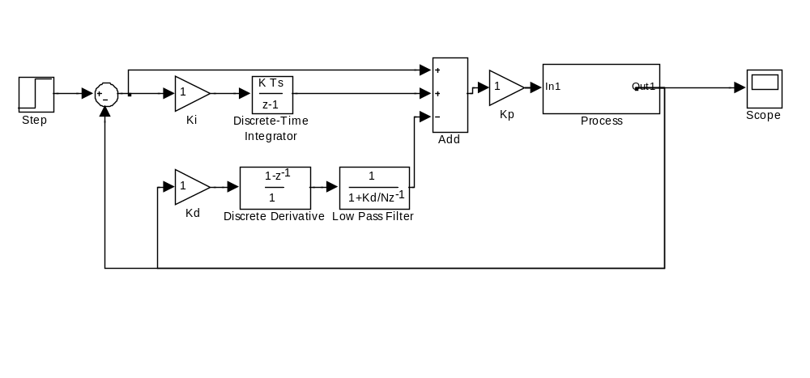
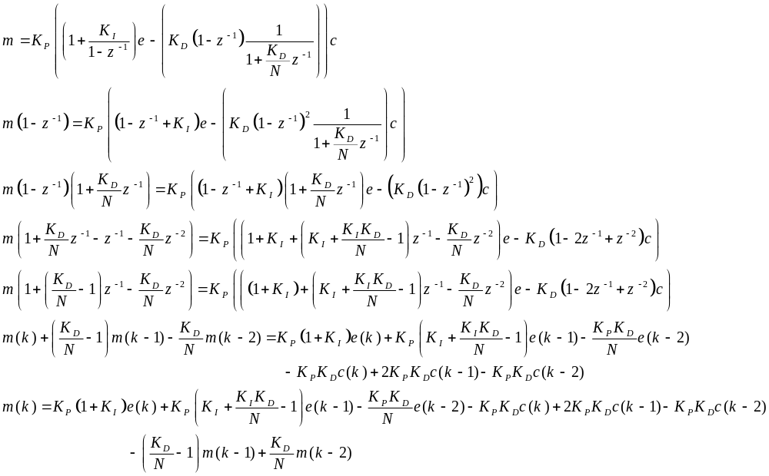
c_prev = c;
c1_prev = c1;
c = get_c();
e = r-c;
e_sum = e_sum + e;
c1 = Kd*(e-e_prev) – Kd/N*c1_prev;
m = Kp*(e + Ki*e_sum –c1);

OR

c_prev_prev = c_prev;
c_prev = c;
m_prev_prev = m_prev;
m_prev = m;
c = get_c();
e = r-c;

m = Kp*((1+Ki)*e + (Ki+Ki*Kd/N-1)*e_prev – Kp*Kd/N*e_prev_prev) – Kd*(c -2*c_prev+c_prev_prev)) -(Kd/N-1)*m_prev + Kd/N*m_prev_prev;

Enhancement 2.0 : Anti-Wind Up Mechanism

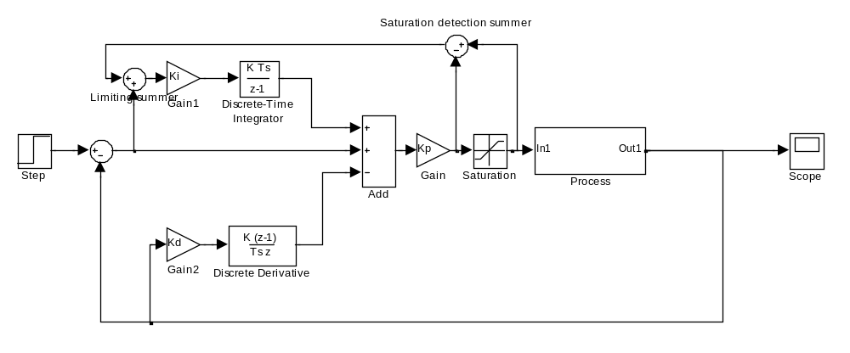
c_prev = c;
c = get_c();
e = r-c;
e_mod = e + m_diff;
e_sum = e_sum + e_mod;
m = Kp*(e + Ki*e_sum – Kd*(c – c_prev));
m_sat = sat(m);
m_diff = m_sat – m;

Enhancement 2.1 : Anti-Wind Up Mechanism with Low Pass Filter

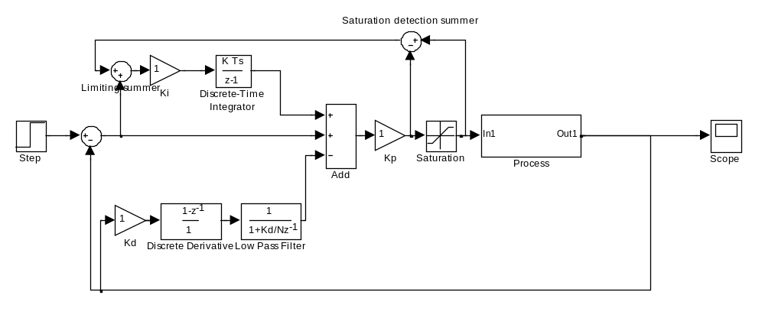
c_prev = c;
c1_prev = c1;
c = get_c();
e = r-c;
e_mod = e + m_diff;
e_sum = e_sum + e_mod;
c1 = Kd*(e-e_prev) – Kd/N*c1_prev;
m = Kp*(e + Ki*e_sum – c1);
m_sat = sat(m);
m_diff = m_sat – m;

